Outland Haven
Game Design

Version 0.1
June 13, 2025

Rimvydas Medimas
Dongseo University
Table of Contents
1. Introduction 3
1.1 Overview 3
2. Game Concept 3
2.1 Core Gameplay Mechanics and Dynamics: 3
2.2 Unique Features: 4
2.3 Inspiration and References: 4
3.Mechanics and Controls 4
3.1 Player Controls 4
3.2 Economy 5
4. Game World, Levels, and Environments 8
4.1 Flow Chart 8
4.2 Progression 9
5. Story and Narrative 9
6. Visual Style and Assets 9
6.1 Visual Style and Art Direction 9
6.2 Concept Art and Design 10
6.3 Asset List (Minimal and Expandable) 10
6.4 Generative AI Tools Plan 10
7. User Interface (UI) and User Experience (UX) 11
7.1 In-Game Menu Layout and Design 11
7.2 HUD (Heads-Up Display) Elements 11
7.3 User Interaction and Feedback 11
7.4 Cut-Scenes and Narrative Presentation 12
8. Audio Design 12
9. Monetization 12
10. Multiplayer Features 12
11. Testing and Quality Assurance 12
12. Marketing and Promotion 12
13. Budget and Resources 12

1. Introduction
This Game Design Document outlines the vision for Outland Haven, a 2D isometric survival and resource management game developed as a bachelor’s final project. The game emphasizes mechanical design over visuals and explores the tension between safety and risk through a town-building and exploration loop. It is intended to showcase thoughtful game systems, progression, and meaningful player decisions.

1.1 Overview
Outland Haven is a single-player 2D isometric game where the player manages a small town as a safe haven while venturing into dangerous, resource-rich territories. The game blends resource gathering, crafting, and strategic upgrades with survival challenges and exploration.
The core gameplay loop involves building up the town, preparing expeditions, and taking calculated risks to obtain rare materials outside the safe zone — all while managing limited resources and permanent consequences.
- Target Audience: Indie gamers, fellow students, and players who enjoy system-driven gameplay focused on mechanics over visuals. Fans of survival, crafting, and exploration genres.
- Genre: Survival, Resource Management, Adventure, Light RPG.
- Theme: Risk vs. Safety, Isolation, Progress through Exploration.

2. Game Concept
This is a 2D isometric game focused on exploration, upgrading, and combat. The player begins in a town, which acts as a safe area where they can craft, upgrade, and prepare for expeditions. To progress, the player must venture outside into hostile areas to gather resources, fight enemies, and return safely.
The core loop revolves around preparation in the town, exploration outside, and upgrading both the character and the town for better chances in future runs. The outside zones are procedurally influenced and failure can mean the loss of some progress, adding tension to every expedition.

2.1 Core Gameplay Mechanics and Dynamics:
Resource gathering, crafting, and upgrades
Exploration-based combat and loot collection
Risk-reward loop (safe zone vs. dangerous area)
Character progression and town development
Light permadeath or punishment mechanics

2.2 Unique Features:
A dual-zone gameplay loop: safe hub and hostile wilds
Minimalist art style with focus on mechanical depth

2.3 Inspiration and References:
Minecraft – Resource gathering and crafting
Path of Exile 2 – Loot variety, enemies, and itemization
Rogue Legacy – Replayability and persistent upgrades
Darkest Dungeon – Planning, safe hub vs. danger zones

3.Mechanics and Controls

3.1 Player Controls
- Movement: 4-directional movement in an isometric view using the keyboard (WASD).
- Interaction/Action: Press E to interact with objects, pick up items, or activate context-sensitive actions.
- Combat:
  - Attack: Shoot an arrow towards the mouse position using the Left Mouse Button.
  - Dodge: Roll or dash in the current movement direction using the Space bar.

- Menu Access: Inventory (I), Map (M), Pause (Esc).

3.2 Economy

The game features four essential resources:
Food – too keep town alive, smith and gear enhancer require food to operate, produced by the farm using crafted tools.

Money – can be obtained from enemies, or by selling material to the smith, used to upgrade weapons and armor.

Material – gathered exclusively from enemies, material has a drop chance after enemy kill, used for gear maintenance or upgrades, can be sold for money.

Knowledge/XP – gathered from killing enemies, gained after killing certain amount of enemies. Used to upgrade a weapon or armor in town gear enhancer.

Farm
Produces food over time, requires tools crafted at the smith to function.

Stash
Stash is for storing resources and other items for further use. It is separate from players inventory, and can be accessed only in town. Space is unlimited.

Smith
Crafts and repairs weapons and gear, requires food to function, uses money and materials for crafting.

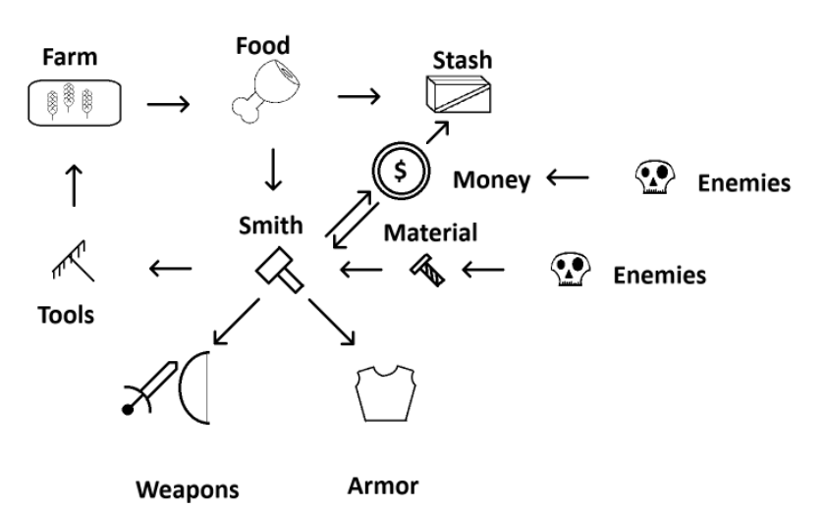
Gear enhancer
Enhancer can permanently upgrade weapon or gear stats like attack speed, damage, health etc. using XP, money and material, requires food to function.

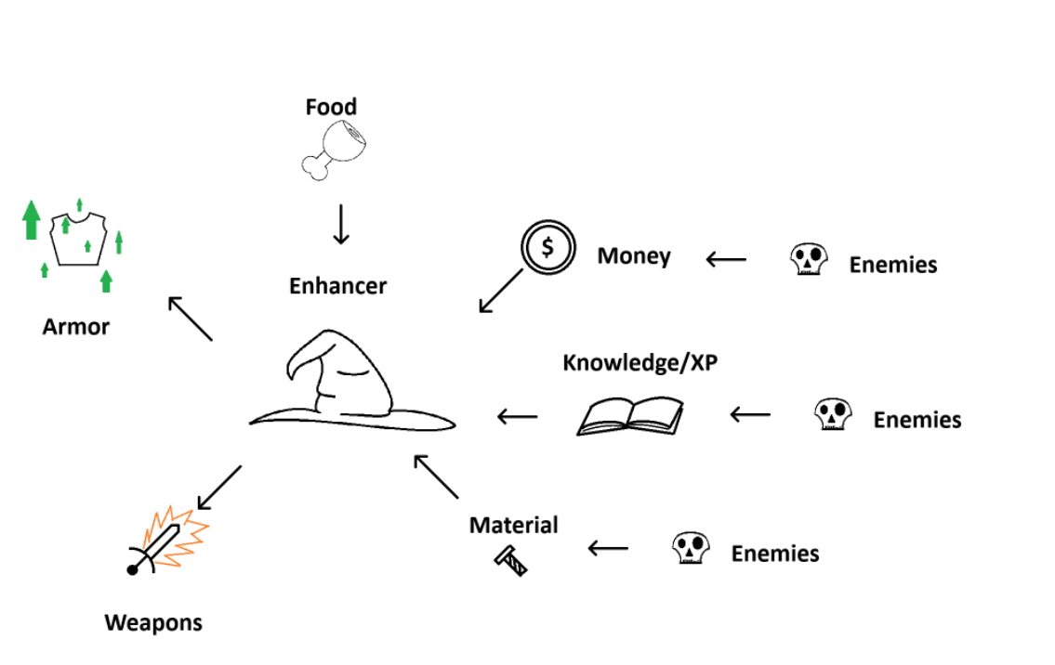

4. Game World, Levels, and Environments

4.1 Flow Chart
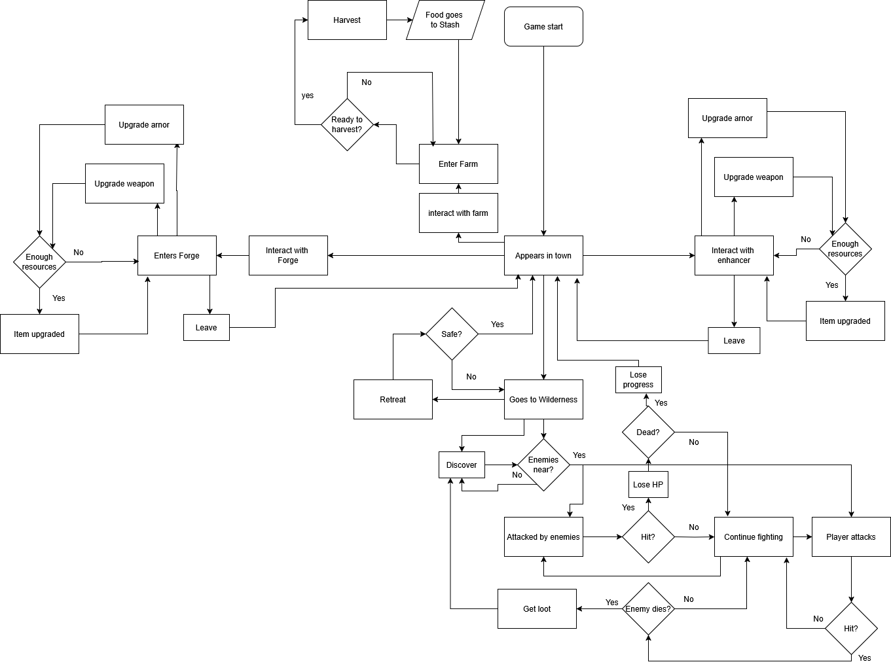

4.1.1 Enemies

exist exclusively within the danger zone and become aggressive only when approached by the player. Their behavior depends on type: ranged enemies shoot projectiles aimed at the player’s current position, while melee enemies attempt to close the distance and strike when in range. All enemies can be defeated by player attacks and will drop loot upon death, which may include currency or crafting materials.

4.1.1 Enemies

4.1.2 Danger zone The danger zone is a dedicated combat area accessed via teleportation from the town. It is an open field filled with hostile enemies and is designed solely for combat and resource gathering. The primary objective is to enter, fight, collect loot, and return safely. However, death within this zone results in the loss of all items currently carried in the player’s inventory. Upon dying, the player respawns in town and suffers a percentage loss of gear durability.

4.1.3 Town serves as a safe hub where the player can store resources, upgrade or repair equipment, and manage the farm. The stash, which provides unlimited storage space, is only accessible within the town. Players can interact with the smith to craft and repair gear using currency and materials, while the gear enhancer allows permanent stat upgrades using XP, money, and materials. The farm produces food, essential for keeping town services operational, and requires tools crafted at the smith to remain functional.

4.2 Progression

, Progression is centered around improving the player's equipment. Weapons and armor can be upgraded through the gear enhancer, increasing attributes such as damage, speed, or durability. These upgrades require materials, money, and XP collected during combat in the danger zone. There are no distinct armor or weapon parts yet—gear is upgraded as a whole. The player grows stronger over time through repeated runs, strategic planning, and efficient resource management between danger zone expeditions and town upgrades.

4.2 Progression

5. Story and Narrative
At this stage of development, the game’s narrative is intentionally left undeveloped to allow the story to evolve naturally as core game-play mechanics are established. The focus remains on designing and implementing robust systems and mechanics first, with narrative elements planned to be layered in later, depending on available time, resources, and design direction.

6. Visual Style and Assets

6.1 Visual Style and Art Direction
The game will use a minimalist pixel art style that focuses on clear readability over aesthetic complexity. The visuals will be functional representations of game states, designed to support gameplay clarity, not artistic expression.
- Perspective: 2D isometric projection
- Resolution: Low-res tiles and sprites (e.g., 16x16 or 32x32 pixels)
- Color palette: Limited palette with high contrast for visibility
- Animation: Minimal or single-frame animations where necessary (e.g., movement, interaction feedback)
- Priority: Clarity of mechanics and feedback loops over visual fidelity
This style supports the developer’s strengths in programming and system design while keeping asset creation and integration manageable for a solo developer.

6.2 Concept Art and Design
The overall atmosphere blends a safe haven town with an ominous and mysterious wilderness. Visual contrast will help the player intuitively understand the risk level of their current area.
- Town: Bright, earthy tones, organized structures, calming layout
- Wilderness: Darker hues, chaotic shapes, ambiguous threats

6.3 Asset List (Minimal and Expandable)
The visual assets will be limited and modular to support rapid iteration and scalability. Below is the minimum viable asset list:
Characters
- Player sprite (idle, walk, attack)
- Basic enemy sprites
Environment
- Ground tiles (town, danger zones)
- Structures (houses, farm plot, forge, etc.)
- Nature elements (trees, rocks, water, etc.), only in town, no obstacles in danger zone
Objects & UI
- Collectibles (wood, stone, food, etc.)
- Crafting station icons
- Health/resource bars
- Simple inventory icons

6.4 Generative AI Tools Plan
AI-generated visuals (e.g., concept art, placeholder sprites) may be used in early development for:
- Mockups
- Visualizing game feel
- Presentation slides
Final in-game assets will be either original or from permissively licensed open-source pixel packs.

7. User Interface (UI) and User Experience (UX)

7.1 In-Game Menu Layout and Design
The user interface will be minimal and efficient, built around keyboard input.
Menus include:
- Main Menu – New Game, Continue, Settings, Exit
- Pause Menu – Resume, Save, Load, Exit to Menu
- Inventory/Crafting Screen – Grid-based, tabbed layout, showing:
  - Item slots (with icons, quantities)
  - Crafting recipes (selectable with feedback)
  - Equipment (player upgrades or tools)
Navigation will be based on arrow/WASD keys and confirm/cancel inputs (e.g., Enter, Esc).

7.2 HUD (Heads-Up Display) Elements
The HUD will display only the most essential information to avoid distracting the player:
- Health bar (bottom left)
- Inventory quick slots or tool belt (bottom)
- Resource counters (money, materials, etc.) with small icons
- Area indicator (e.g., “Town”, “Wilderness”) with subtle color-coded zone bar
The HUD adapts slightly depending on the area — for example, showing combat stats or threat levels when outside the town.

7.3 User Interaction and Feedback
Player input will follow a responsive and clean design:
- Keyboard WASD for movement, E for interact, I for inventory, etc.
- Mouse for aiming and shooting projectiles.
- Visual feedback for:
  - Successful collection or interaction (e.g., popup or color flash)
  - Errors (e.g., grayed-out button, sound cue)
  - Damage taken (screen flash or shake effect)
- Context-sensitive interactions: prompt when near objects or structures (e.g., “Press E to harvest”)

7.4 Cut-Scenes and Narrative Presentation
Since the project is solo and lightweight in art, cut-scenes will be minimal and primarily text/dialogue driven, with optional static illustrations or stylized screens.

8. Audio Design
Audio in the game serves a functional and atmospheric role, using simple, open-source sounds to reinforce player actions and establish a minimal yet immersive environment. The design avoids complexity, focusing on clarity and feedback rather than rich soundscapes.

9. Monetization
The game will follow a fixed-price model with no in-game purchases or microtransactions.

10. Multiplayer Features
The game is a single-player experience with no multiplayer, networking, or co-op features planned.

11. Testing and Quality Assurance
The QA process will focus on building a stable and bug-free core gameplay loop, serving as a reliable foundation for future features and content updates. Initial testing will be done manually through frequent playtesting and iteration during development. Bugs will be tracked in a simple spreadsheet or issue tracker, categorized by severity and priority. The goal is to maintain a clean, stable canvas that ensures new systems can be added without introducing critical regressions or gameplay breaking issues.

12. Marketing and Promotion
The target audience includes indie game enthusiasts, fellow students, and players who enjoy adventure, combat, and resource management games with a focus on gameplay mechanics. Marketing will primarily rely on social media platforms, indie game forums, and student communities to build awareness. Key selling points are the deep gameplay systems, replayability, and a clear distinction between safe and combat zones, all wrapped in a simple, pixel-art style focused on mechanics rather than visuals.

13. Budget and Resources
Estimated Development Costs
As a solo student project, development relies primarily on free tools and open-source resources, minimizing financial costs. Main costs are related to time investment and potential optional assets.

Item Estimated Cost
Development Software (IDE, tools) Free (Visual Studio, Unity, etc.)
Art and Sound Assets Free/Open source
Personal Computer and Peripherals Already owned
Optional: Paid Assets or Tools ~€0–100 (if needed)

Resource Allocation
- Time: Solo development over 12 months.
- Personnel: One person (developer, designer, planner).
- Technology:
  - Programming: C#, Unity
  - Graphics: Simple pixel art (self-made or open-source)
  - Sound: Free libraries
- Version Control: Git (GitHub)

